**PERFORMANCE ANALYSIS AND SIMULATION OF DATA STRUCTURE ALGORITHMS**



**2022-23**

##### A PROJECT REPORT

###### ***Submitted by***

**SANJANA S 201231522136**

**SAPTHAMI CHTRA 201231522226**

**PREETI JANARDHAN NAIK 201231522213**

In partial fulfillment for the award of the degree of

##### BACHELOR OF COMPUTER APPLICATIONS

***Under the guidance of***

**Mr. GANESH K**

Lecturer

Department of Computer Science

**BHANDARKARS’ ARTS AND SCIENCE COLLEGE KUNDAPURA**

MANGALORE UNIVERSITY

**BHANDARKARS’ ARTS AND SCIENCE COLLEGE**

**KUNDAPURA -576201**



Department of Computer Science

Certified that the project work entitled

**PERFORMANCE ANALYSIS AND SIMULATION OF DATA STRUCTURE ALGORITHMS**

is a bonafied work carried out by

**SAPTHAMI CHATRA PREETI JANARDHAN NAIK SANJANA S**

in partial fulfilment for the award of degree of Bachelor of Computer Applications of the Mangalore University during the year 2022-23. The project report has been approved as it satisfies the academic requirements of project work prescribed for the Bachelor of Computer Applications.

**Project Guide Head of the Department**

**Department of Computer Science**

Sapthami Chatra Sanjana S Preeti J.Naik

**Name of the Student:**

200604 200579 200602

**Roll Number:**

201231522226 201231522136 201231522213

**University Register Number:**

**Examiners: 1. 2.**

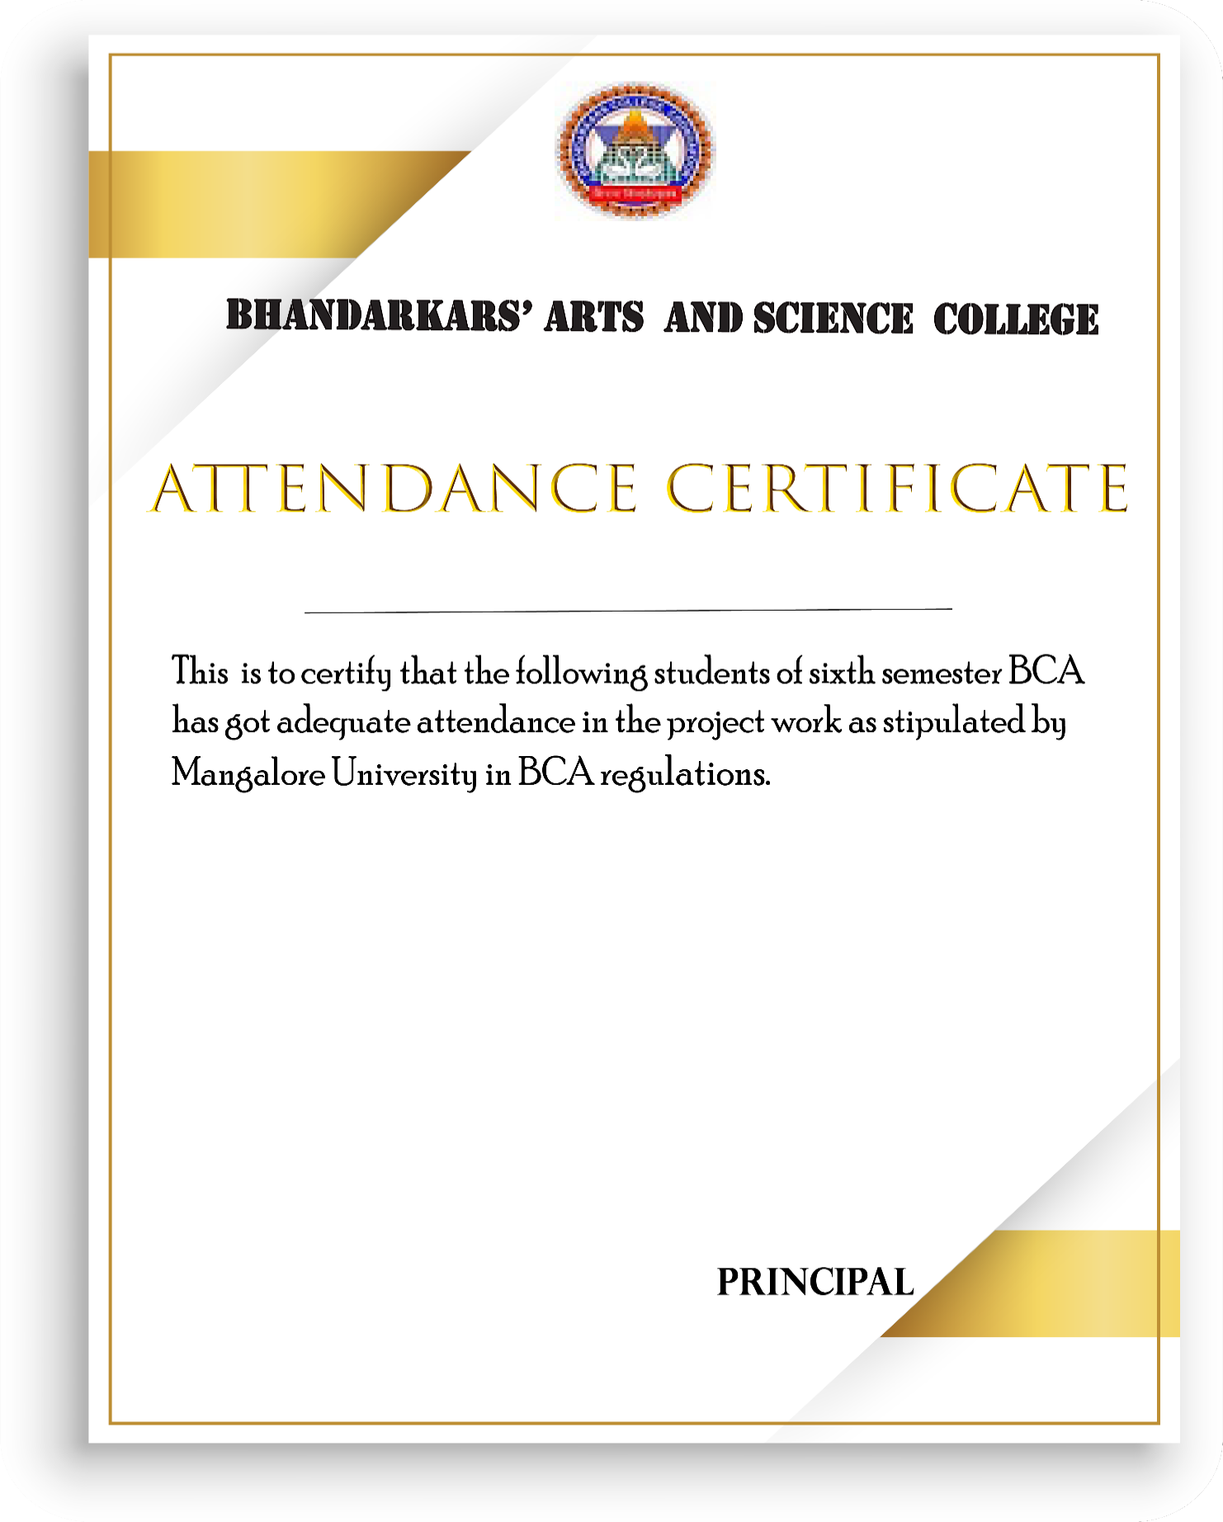

KUNDAPURA-576201

SANJANA S :201231522136

SAPTHAMI CHATRA :201231522226

PREETI JANARDHAN NAIK :201231522213